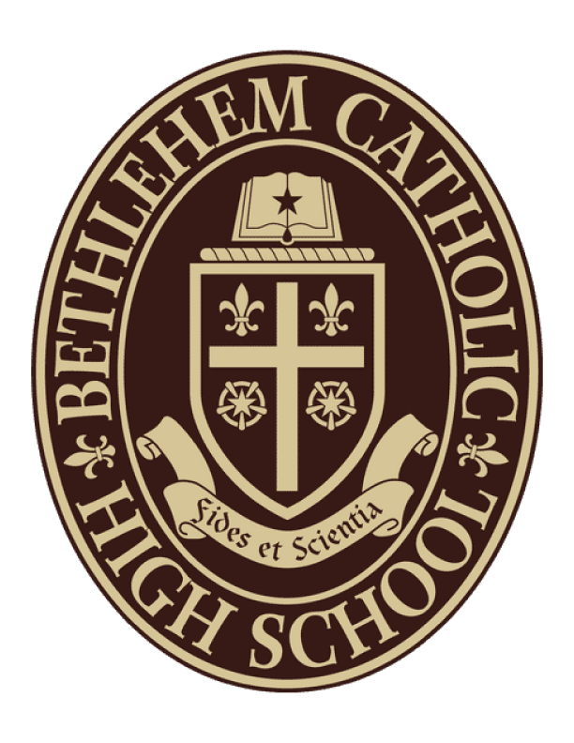

BETHLEHEM CATHOLIC
HIGH SCHOOL
School Calendar / 2023-2024
Updated: 9/28/23

OCTOBER 2023
02 – Faculty Meeting
02 – In-school Retreat (Mass Included)
03 – OLPH 8th Grade Visit
04 – Elizabeth McNulty (Pro-Life Speaker)
06 – Notre Dame Marathon
06 – First Friday Eucharistic Adoration
09 – Diocesan Convention @ Notre Dame H.S.
Teacher In-Service (Schools Closed)
10 – St. Anne’s 8th Grade Visit
10 – Graduation Assembly with Seniors (8AM)
11 – PSAT Testing (Juniors, Sophomores,
Freshman)
13 – Cougar Crawl
15 – NHS Induction and Presentation of
Top Ten Scholars
16 – PA March for Life (7AM-3PM)
18 – Holy Infancy 8th Grade Visit
19 – Notre Dame 8th Grade Visit
22 – 8th Grade Confirmation Retreat
25 – St. Michael The Archangel
8th Grade Visit
26 – School Mass
29 – Bethlehem Halloween Parade
30 – 2nd Quarter Begins
31 – Faculty Fall Lunch

NOVEMBER 2023
01 – All Saints Day School Mass
03 – First Friday Eucharistic Adoration
03-05 – Jr./Sr. Weekend Retreat
06 – Faculty Meeting
09-10 – Fr./So. Overnight Retreat
10 – Veteran’s Day Event
12 – Open House (2-4PM)
21 – Thanksgiving Mass/Food Drive
22 – Thanksgiving Holiday Begins
Teacher's Day of Recollection
(Schools Closed)
23-24 – Thanksgiving Holiday (Schools Closed)
27 – Thanksgiving Holiday (Schools Closed)
TBD – In-school Retreat & Forty Hours

DECEMBER 2023
01 – First Friday Eucharistic Adoration
01-03 – Partner School Christmas Play
(Fri 7PM, Sat 7PM, Sun 3PM)
04 – Faculty Meeting
08 – Immaculate Conception School Mass
12 – First Grade Christmas Party
(Snow Date 12/13)
14 – Advent Confessions
14 – Twilight Retreat (Snow Date 12/21)
15 – Christmas Concert (Snow Date 12/16)
19 – Candlemass at Beginning of Day/
Special Schedule (Snow Date 12/20)
22 – 11:30 am Dismissal/
Faculty Christmas Party
25-29 – Christmas Holiday Begins
(Schools Closed)

JANUARY 2024
01 – New Year’s Day (Schools Closed)
02 – New Year’s Holiday (Schools Closed)
03 – Classes Resume, School Mass
05 – First Friday Eucharistic Adoration
05-07 – Winter Play
(Fri 7PM, Sat 7PM, Sun 3PM)
12-14 – Winter Play Snow Makeup Dates
15 – Martin Luther King Jr. Day
Teacher In-Service (School Closed)
16-19 – Midterm Exams-11:30 Dismissal
(1A-1B, 2A-2B, 3A-3B, 4A-4B)
19-21 – Jr./Sr. Weekend Retreat
22 – 3rd Quarter Begins
28 – Speakers in Parishes that do not have
Schools
28-2/03 – Catholic Schools Week Begins
29 – School Mass with Bishop Schlert

FEBRUARY 2024
02 – First Friday
03-04 – Diocesan Music Festival
04 – Open House (2-4PM)
08-09 – Fr./So. Overnight Retreat
14 – School Mass (Ash Wednesday)
15 – Partner School Music Festival
19 – President’s Day (Schools Closed)
29 – School Mass

MARCH 2024
01 – First Friday Eucharistic Adoration
01-03 – Jr./Sr. Weekend Retreat
07 – School Mass
14 – Lenten Confessions
(Makeup Date 3/20)
21 – Stations (1:30PM)
23 – Golden Gala (5:00PM)
26 – School Mass
28 – Easter Holiday Begins
Holy Thursday Evening Church Visitation
(Schools Closed)
29 – Good Friday (Schools Closed)
TBD – Faith Sharing 4th Grade

APRIL 2024
01 – Easter Holiday (Schools Closed)
02 – 4th Quarter Begins
02-04 – NCEA Convention
03 – Partner School Visit Play
05 – First Friday
05-07 – Spring Musical
11 – School Mass
12-14 – Spring Musical
18 – Distinguished Graduates Ceremony
22 – School Mass
23-26 – Middle States
23-27 – Band Trip
30 – 7th Grade Field Day

MAY 2024
03 – First Friday
06-10 – AP Testing
09 – Mass (Ascension Thursday)
10 – Junior Senior Prom
13-17 – AP Testing
18 – Placement Testing for Incoming
Freshman
22 – Senior Signing Day (8:30AM)
24 – Senior Farewell School Mass
27 – Memorial Day (Schools Closed)
28-31 – Senior Friday
31 – Finals Exams

JUNE 2024
03-05 – Final Exams
03 – Baccalaureate Practice
04 – Graduation Practice
04 – Baccalaureate Mass (7:00PM) @ St. Anne’s
05 – Graduation (7:00PM)
06 – Closing Exercises/Mass
Faculty Reception to Follow
10 – Accelerated Credit Classes Begin
17 – Credit Recovery Classes Begin

